# Odor memory training in old adults: behavioral and cortical effects of transfer from olfactory to visual memory

*Jonas K. Olofsson*1,2,3*, Maria Larsson*1*, Ingrid Ekström*1,4*, Marta Zakrzewska*1*, Joanna Lindström*1*, Behzad Iravani*5*, Rouslan Sitnikov*5*, Elmeri Syrjänen*1*, Johan N. Lundström*3,5

**Affiliations**:1 Gösta Ekman Laboratory, Department of Psychology, Stockholm University, Stockholm, Sweden; 2 Swedish Collegium of Advanced Study, Uppsala, Sweden; 3 Stockholm University Brain Imaging Center, Stockholm University, Stockholm, Sweden; 4 Aging Research Center, Karolinska Institutet, Stockholm, Sweden; 5 Department of Clinical Neuroscience, Karolinska Institutet, Stockholm, Sweden;

**Author contributions:** The study concept was developed by J.K.O. Authors J.K.O, R.S., M.L., I.E. contributed to the study design. Data collection was conducted by authors I.E., J.L, M.Z., and E.S., under the supervision of J.K.O and M.L. Data analysis was conducted by authors B.I. and J.L. Authors J.K.O, B.I, J.N.L., and I.E drafted the manuscript, which was revised based on input from all other authors. All authors approved of the final version of the manuscript.

**Corresponding author:** Jonas K. Olofsson. Email: [Jonas.olofsson@psychology.su.se](mailto:Jonas.olofsson@psychology.su.se); tel: +46-8-163840; fax: +46-8-162000.

**Word count:** xxxx (intro, methods, results discussion, tables figures and legends)

# Abstract

Engagement in cognitively stimulating activities has been proposed to alleviate memory loss in older adults, but results are controversial because training rarely transfers to improvements in unrelated and untrained tasks. This study was based on a hypothesis, emerging from prior experimentation in younger adults, that a memory task using odors as target stimuli would lead to transfer to a visual task, but that the visual task would not generate transfer to the olfactory task. This concept is called “asymmetric transfer” and we investigated whether the results would be similar in older adults, as well as investigate the cortical correlates. Here, older adults trained on one of two memory tasks daily for 40 days. Pre-training and post-training assessments of olfactory and cognitive abilities were conducted, as well as a resting-state fMRI protocol to map connectivity changes within individuals as a function of training paradigm and relate such changes to group-level behavioral effects of interest. We found that a similar behavioral effect was obtained, as evidence of “asymmetric transfer” in old adults, but further transfer to untrained olfactory or visual cognitive tasks was not observed. Resting-state fMRI data resulted in training-related changes that depended further on the training intervention, where increased “hubness” in fronto-parietal transmodal cortical areas were more present in olfactory, compared to visual training groups. Moreover, posterior parietal cortex thickness increase, and functional hubness increase in an adjacent parietal area, was associated with the magnitude of behavioral transfer from the olfactory to the visual task. The results indicate that olfactory-based memory training in old adults may transfer to a similar visual task, and suggest that olfactory-specific engagement of transmodal cortical areas are responsible for such transfer.

# Introduction

Can odor-based memory training provide generalized cognitive benefits? Olfactory abilities are often impaired in old age; these impairments lead to a compromized quality of life (Altundag et al., 2015). (Larsson, Nilsson, Olofsson, & Nordin, 2004). Olfactory decline is in some cases a sign of emerging dementia disorders or ongoing cognitive decline (Josefsson, Larsson, Nordin, Adolfsson, & Olofsson, 2017; Olofsson et al., 2009). Methods for enhancing olfaction are emerging, as these may help to alleviate olfactory loss. Whether olfactory-based cognitive interventions may lead to improvement on non-olfactory tasks is yet unknown.

Olfactory-based perceptual training is associated with hemodynamic brain changes, that depend on the sensory and cognitive demands of the training task. In healthy adult participants, learning to name familiar smells resulted in hemodynamic changes in regions the superior frontal gyrus and parietal areas during a naming task (Fournel et al., 2017). In older adults, olfactory training is associated with X and Y. These results suggest that olfactory training might benefit cortical networks supporting cognitive functions, well beyond the olfactory domain.

In the present work, we devised an olfactory memory training protocol for older adults. The olfactory memory training protocol was recently shown to benefit olfactory discrimination abilities, odor naming abilities, but most importantly, the olfactory memory training protocol benefitted also performance in a non-olfactory game with a similar format (Olofsson et al., 2017)(Olofsson et al under review). In contrast, a control group that trained on the visual game showed no benefits on the olfactory tasks.

The results observed in younger adults suggest that gains from olfactory memory training might transfer to non-olfactory tasks. If such cross-sensory generalization of learning is possible, and if the transfer is present only as olfaction-to-vision but not as vision-to-olfaction, as our prior research suggests, what are the cortical systems that mediates such learning effects?

To understand the cortical systems affected by our memory training protocol, all subjects underwent a resting-state fMRI scan before and after 40 days of training, and their cortical thickness was assessed by voxel-based morphometry. This allowed us to analyze individual-level changes due to training as measured by behavioral gain as well as cortical activity and morphological changes. These comparisons were used to address our main hypothesis, that olfactory memory training would lead to transfer to a visual memory task (but visual training would not lead to olfactory transfer), and that this transfer would be associated with resting-state changes as well as morphometric changes in cognitive systems of the brain. We also tested all participants, pre-training and post-training, on untrained olfactory tasks as well as untrained visual cognitive/neuropsychological tasks. These tasks were included to observe the possible generalizability (”far transfer”) to untrained tasks of a different domain and sensory modality. These tasks were aimed at exploring the limits of our hypothesized transfer effects.

# Materials and Methods

## *Participants*

Participants (n=41) were recruited to olfactory and visual memory training conditions by means of advertising, mainly through a designated website for research study advertisements. The advertisement stated that participants would train at home with a memory game for 40 days and that cognitive and perceptive functions would be tested before and after the training-period in a laboratory setting, including fMRI. Exclusion criteria were neurologic or psychiatric disorders, colds, allergies or breathing problems, and olfactory or uncorrected visual impairments. Participants were randomly assigned to either olfactory memory (OM) or visual memory (VM) training groups, and were tested by trained research assistants who were blind to the type of training assigned to the participants. Participants were compensated monetarily after completion of the training program (1500 SEK). Forty-one participants completed the memory training; 21 with the olfactory memory task (OM) and 20 with the visual memory task (VM). XX participants did not complete memory training or did not follow the strict protocol (XX OM, XX VM). Additionally, X participants were excluded due to technical or experimenter errors during initial testing).

## *Training tasks*

As in our prior work (Olofsson et al submitted), the olfactory memory game (OM) included 24 tin cans, containing 12 different kinds of commercially available flavored teas, to make up 12 stimulus pairs. Two parallel, non-overlapping sets were constructed. A game-size consisting of 12 cans was chosen after evaluating different amounts of stimulus pairs and their effect on average game time, perceived difficulty of the task and perceived enjoyment of the task in a pilot-study. The odors within the sets were carefully selected for perceptual distinctiveness, to avoid influences on game performance by normal variations in odor discrimination ability. Examples of flavors that were used in the odor game are “vanilla”, “strawberry”, “cinnamon”, “orange”, “peppermint”, “almond”, “licorice” and “ginger”. Odors were placed in identical white cotton bags to prevent visual identification. The cans were randomly distributed on a board that included 24 squares arranged in a 6-by-4 grid. On each trial, the player sampled two tin cans of choice and compared their content. Upon detecting a match, the matched items were removed from the board. As the player seeks out matching odor qualities and removes them, high level of performance is thus predicated on accurate perception of odor quality and retention of the odors’ spatial locations across trials. Performance was measured as the number of trials required to empty the board, with fewer trials indicating higher performance. In order to establish certainty and thus accurate performance logs, each tin can was marked at the bottom with a barcode that was unique to each can but mirror-inverted for the can holding the matching pair. Thus, participants could easily verify a match by turning two cans upside down and holding the barcodes next to each other. The barcodes are exceptionally difficult to dissociate and remember and they are not visible while playing, and would thus have minimal supporting influence on memory performance.

A visual memory (VM) game was devised as an active control task. Here, 12 different language symbols were obtained from Korean and Mandarin Chinese languages, and placed at the bottom of the tin cans. Based on evaluation in a pilot-study, these symbols were chosen in order to establish a visual memory game that matched the olfactory game in difficulty, complexity, and enjoyment, in order to make the two tasks similar in all other aspects except the engagement of olfactory vs. visual objects. The symbols were unfamiliar to our Swedish participants. Two parallel, non-overlapping sets were constructed. Memory training was carried out similarly to the OM game.

## *Bayesian statistical analysis on behavioral data*

For train gain, transfer gain, olfaction performance or cognition performance a linear Bayesian regression model fitted to data with age and training group as dependent variable. In olfactory tasks we used an informed prior based on results from (Olofsson et al 2020). In cognititive tasks, we used a diffuse prior because no prior data were available.

The posterior distribution was estimated using Markov Chain Monte Carlo (MCMC) with 10,000 samples. First, 1000 samples were removed to let the algorithm leave a transient state and five samples were kept to minimize temporal dependency.

## *Voxel wise morphometry (VBM) and statistical analysis*

Segmented T1-weighted images with different tissue classes, namely gray matter white matter and cerebrospinal fluid compartments were intensity bias was corrected. Then, all images were registered using linear (12-parameter affine) and warped within a unified model ([Ashburner and Friston, 2005](https://www.sciencedirect.com/science/article/pii/S0006899310013041#bib27)). Finally, the modulated volumes were smoothed with a Gaussian kernel of 8 mm full width at half maximum (FWHM). The voxel-wise change in gray matter (GM) volume were examined across to two time points (i.e. pre and post) in general linear model frame work with total brain volume, age, gender, train gain and transfer gain as dependent variables. Age, gender and total brain volume were considered as nuisance effects.

## Resting State fMRI

### Image acquisition

Place holder …….

### *Preprocessing*

Resting-State fMRI data were preprocessed using Statistical Parametric Mapping (SPM12; Welcome Department of Cognitive Neurology, University College London, London, United Kingdom). After slice-time correction, motion within images were correct by rigid aligning each volume to middle volume. In addition, T1-weighted images were co-register to the average of fMRI images. Co-registered T1-weighted images were segmented to different tissue classes. Lastly, preprocessed fMRI images were affine transformed to Montreal Neurological Institute (MNI) template space and smoothed with a Gaussian kernel of 8 mm full width at half maximum (FWHM).

Using movement parameters that were extracted in realignment step we calculated frame-wise displacement (FD){ [# REF to J.Power https://dx.doi.org/10.1016%2Fj.neuroimage.2011.10.018 r](%20# REF to J.Power https://dx.doi.org/10.1016%2Fj.neuroimage.2011.10.018 r) } . Then, we scrubbed fMRI data to remove the effect of movement using calculated FD and global signal by removing images (including one before and after the incident) where global signal or FD were higher than 2 SD form the average and interpolate it with nearest neighborhood (Figure 1).

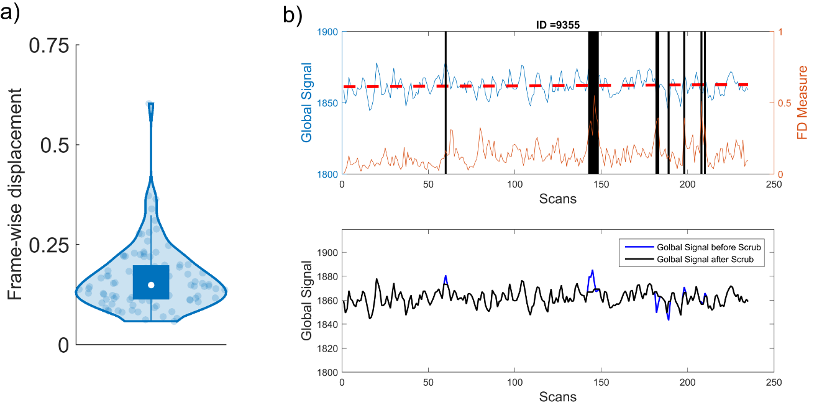

Figure 1 a) frame-wise displacement distribution b) scrubbing procedure on a representative subject, time points at which either global signal or frame-wise displacement were bigger that 2 SD from average identified and scans at those time points, one before and after time points removed and interpolated using nearest neighborhood algorithm.

Afterwards, the variance explained by global signal simultaneously removed along with band pass filtering [0.01 ~ 0.1 Hz] the rsfMRI data. Time series of different anatomical regions as defined in the AAL atlas in addition to, olfactory regions defined in {# REF to Janina’s ROIs} were extracted and functional connectivity (FC) matrix was constructed using person correlation followed by fisher z-transformation. The connectivity matrix was scattered by keeping connections that significantly changed from pre-training to post-training with the criterion p < 0.05 uncorrected for false alarm rate.

### *Seed-based correlation analysis*

In the seed based correlation analysis (SCA) we used two clusters found in the VBM analysis for olfactory group which showed significant volume increase for transfer gain compared to train gain. The FC pattern of each seeds was derived using person correlation in both conditions. The FC maps passed through fisher z transformation and the change in FCs achieved by subtracting post-training patterns from pre-training patterns. On the second level, GLM analysis performed in voxel-wise manner on the change in the FC’s patterns with age, gender, train gain and transfer gain as dependent variables.

### *Graph theory*

We used graph theory to investigate the changes in FCs on a whole–brain scale caused by olfactory training versus visual training. We computed nodal degree as a measure of centrality for anatomical regions that significantly changed from pre-training to post-training across two conditions (i.e. olfactory training and visual training) [{# REF Sporns DOI10.1038/nrn2575](https://www.nature.com/articles/nrn2575" \t "_blank)}. For each condition, nodes with a degree of 2 SD higher than average were identified as central brain nodes, or hubs, in training (Fig1.).

Results

*Olfactory memory training yields benefits in visual memory game*

We found moderate evidence (BF10 = 3.42) against null hypothesis, suggesting that transfer gain (pre-post changes in the untrained task) was different as a function of training group (Figure 2). The estimated posterior suggested that on average, the transfer gain was 6 units bigger for the olfactory training group compared to the visual training group. However, we observed no clear evidence (BF01 = 1.05) for training gain as function of training groups, suggesting training benefit (and, we infer, task difficulty) was equal across tasks.

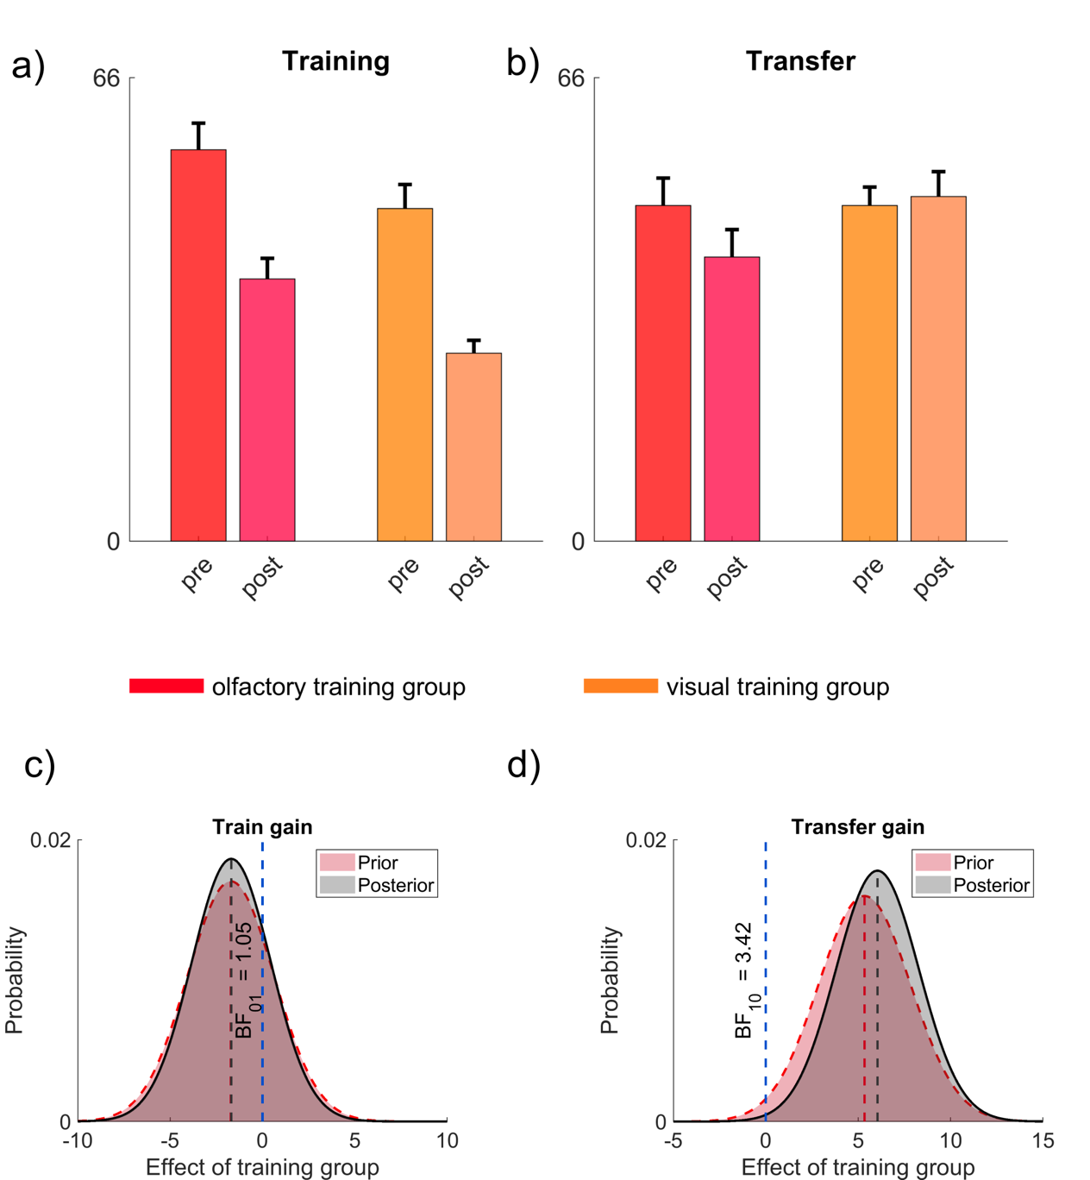

**Figure 2** a) Memory game performance on the trained task b) Transfer performance in memory game on non-trained task c) MCMC estimation of posterior distribution of train gain in black and the prior probability in red as function of training group. There is an anecdotal evidence (BF01 = 1.05) against null hypothesis (no effect of training group for train gain) d) MCMC estimation of posterior distribution of transfer gain in black and the prior probability in red as a function of training group. There is moderate evidence (BF10 = 3.42) against null hypothesis (effect of training group on transfer gain)

*Cognition and olfactory performance did not change across training groups*

The was an anecdotal evidence for change in cognition and olfactory performance as function of training group (Figure 3.).

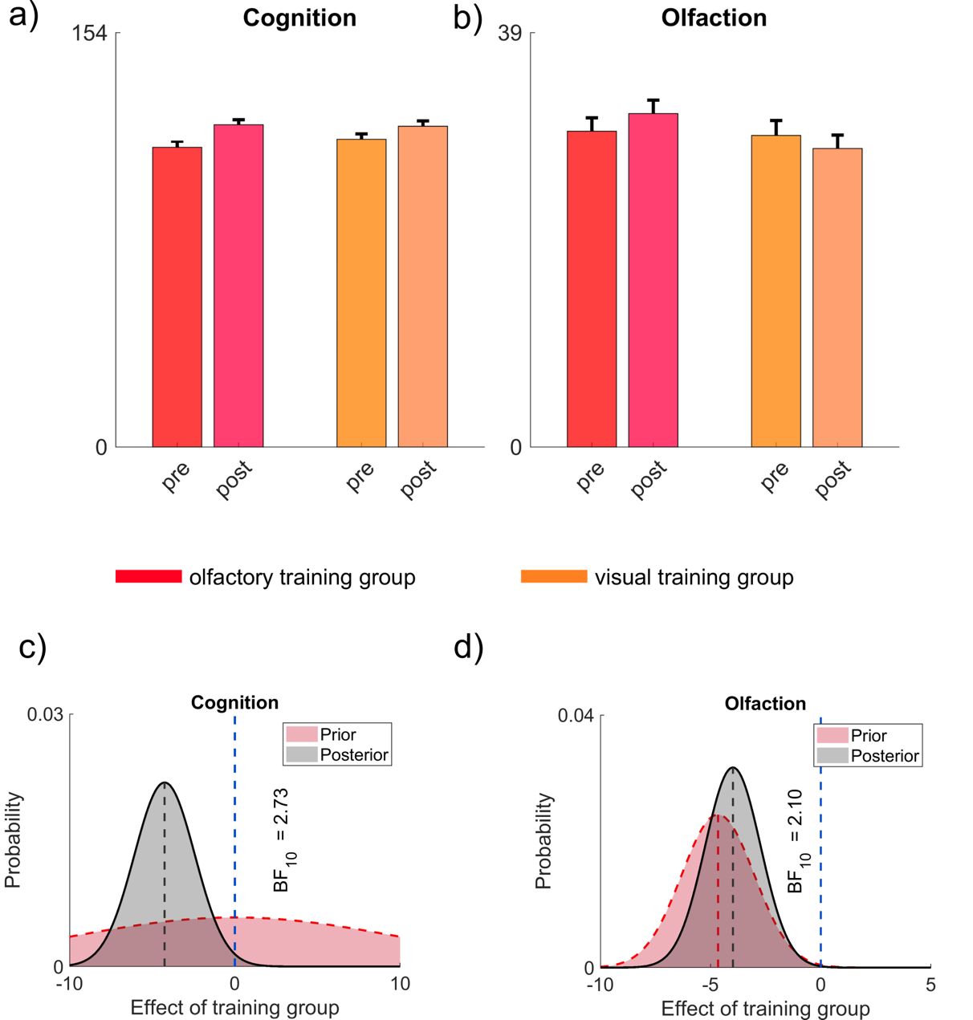

Figure 3 a) cognitive performance pre and post-training across training groups b) Olfactory function pre and post-training across training groups c)MCMC estimation of posterior distribution of change in cognition performance in black and the diffused prior probability (mu = 0; sigma = 50) in red as function of training group. There is an anecdotal evidence (BF10 = 2.73) against null d) MCMC estimation of posterior distribution of change in olfactory performance in black and the prior probability in red as a function of training group. There is anecdotal evidence (BF10 = 2.10) against null hypothesis.

Morphological change in multisensory regions associates more with transfer gain

We found that two clusters in post-central gyrus lobe (PCG; t (18) = 5.15 p < 0.0005 k=50) and superior parietal lobule (SPL; t (18) = 4.77 p < 0.0005 k=50) increased volume more for transfer gain compared to train gain (Figure 4)

**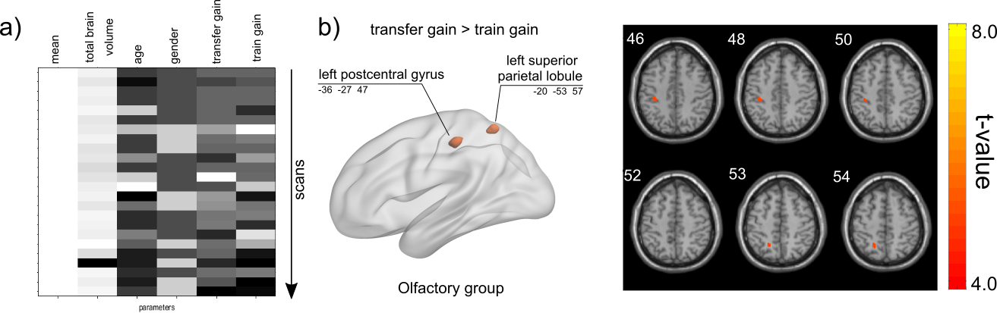**

Figure 4. a) Design matrix b) Increased volume more for left postcentral and left superior parietal lobe (IPS region) for transfer gain rather than train gain in olfactory group

## Visual training increased volume in memory/learning areas

For visual group same analysis performed and no change found for transfer gain but one cluster in isthmus of cingulate gyrus (episodic/semantic memory related region (t (12) = 9.54 p < 0.0002 K=50) and anterior cingulate cortex (t (12) = 7.28 p < 0.0002 K=50) found that showed increase in volume more for train gain rather than transfer gain Figure 5.

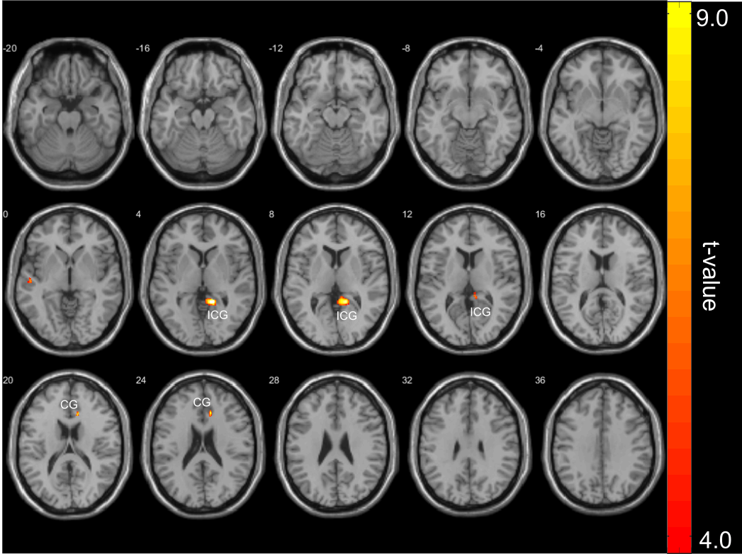

Figure 5. Increase in volume more for train gain compared to transfer gain

## Transfer gain explains by FC between medial frontal gyrus and superior parietal lobule

We found the significant change in FC between left SPL seed and part of left medial front gyrus (MFG) explain transfer gain (t (18) = 5.97 p < 0.0005 K=20) Figure 6 a. SPL is functionally connected to PCG seed followed by connection to Calcarine Figure 4 b.

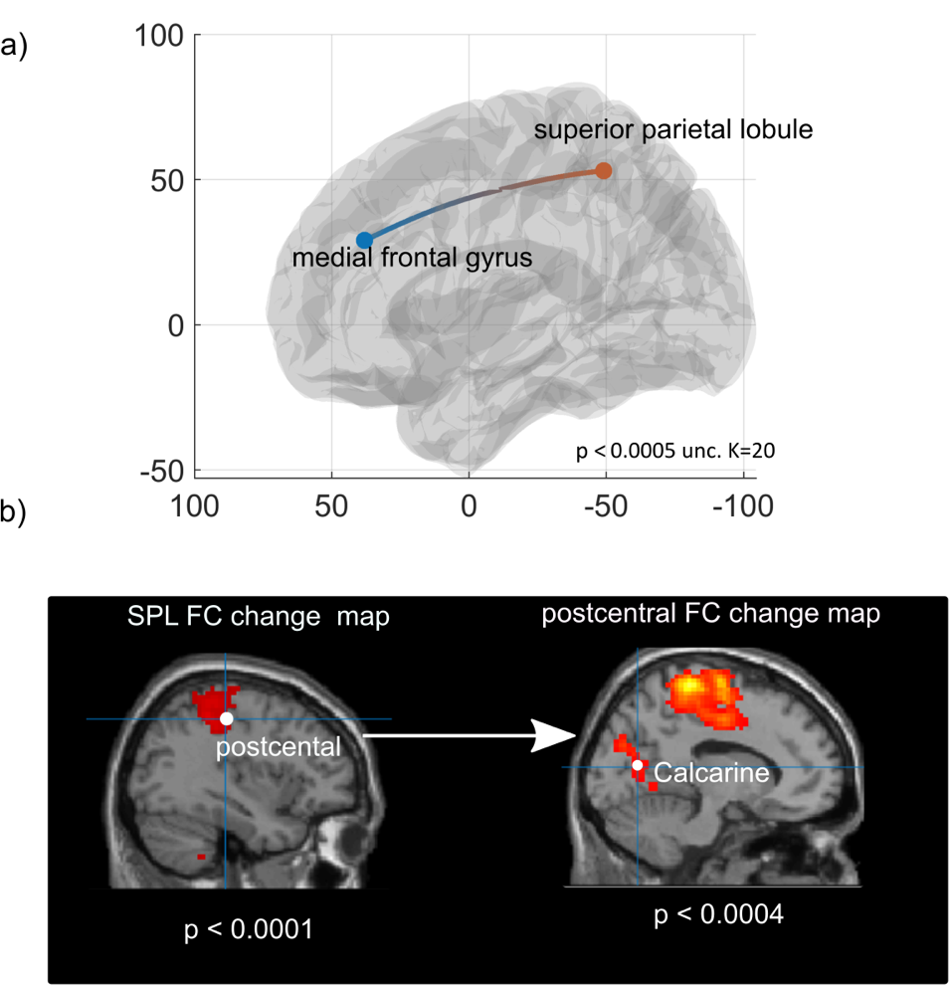

Figure 6 a) functional connectivity between medial frontal gyrus and superior parietal lobule has an association with transfer gain b) left connectivity map for

## Olfactory training increase centrality in frontal and multisensory regions

In olfactory training group left superior frontal gyrus (SFG; Z= 2.51 p < 0.01), left medial frontal gyrus (MFG; Z = 2.89 p < 0.01), and angular gyrus (AnG; Z = 2.51 p < 0.01) showed increased in centrality compared to pre-training (Figure 7).

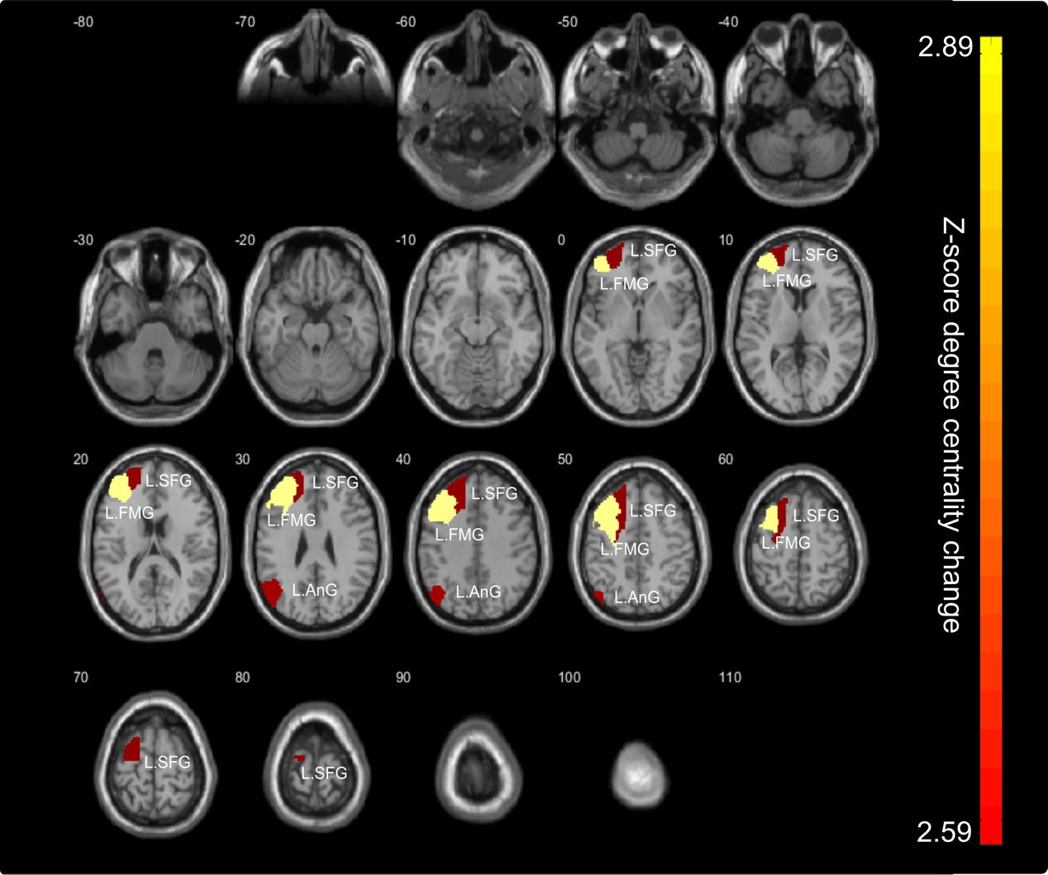

Figure 7) Centrality of left superior frontal gyrus, left frontal medial gyrus and left angular gyrus increased for olfactory training group (p < 0.01)

## Visual training increase centrality in right language, visual and left putamen

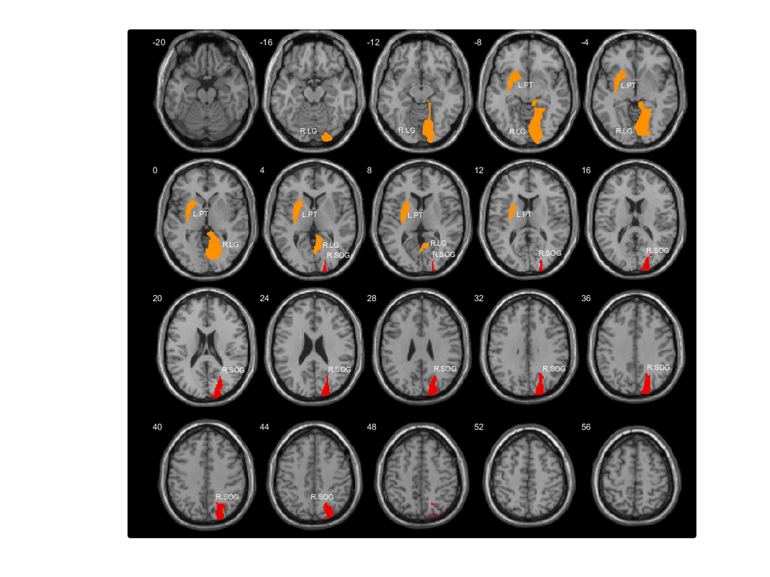

Figure 8

## Association between olfactory training gain and right superior marginal, right medial supplementary motor and left paracentral lobule regions

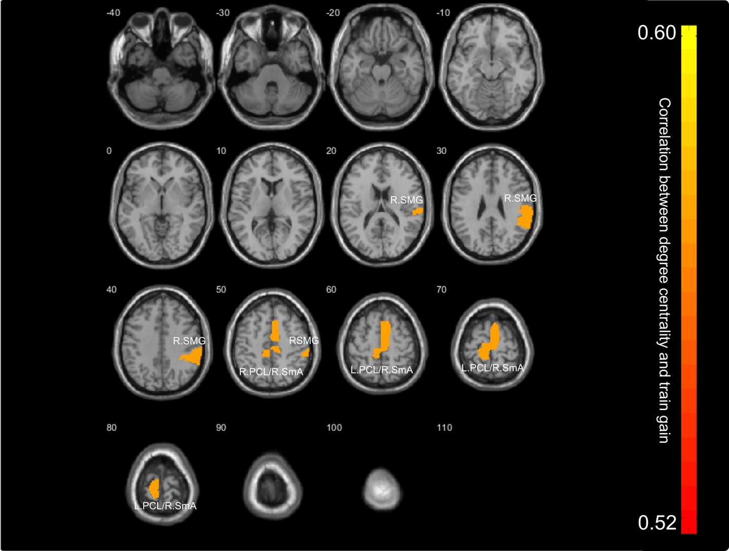

Figure 9

## Transfer gain in olfactory group and training gain in visual group is linked to right inferior frontal gyrus

Changed in centrality of right inferior frontal gyrus (R.IFG) is linked both to visual train gain (rho = 0.56 p < 0.05) and olfactory transfer gain (rho = 0.56 p < 0.05).

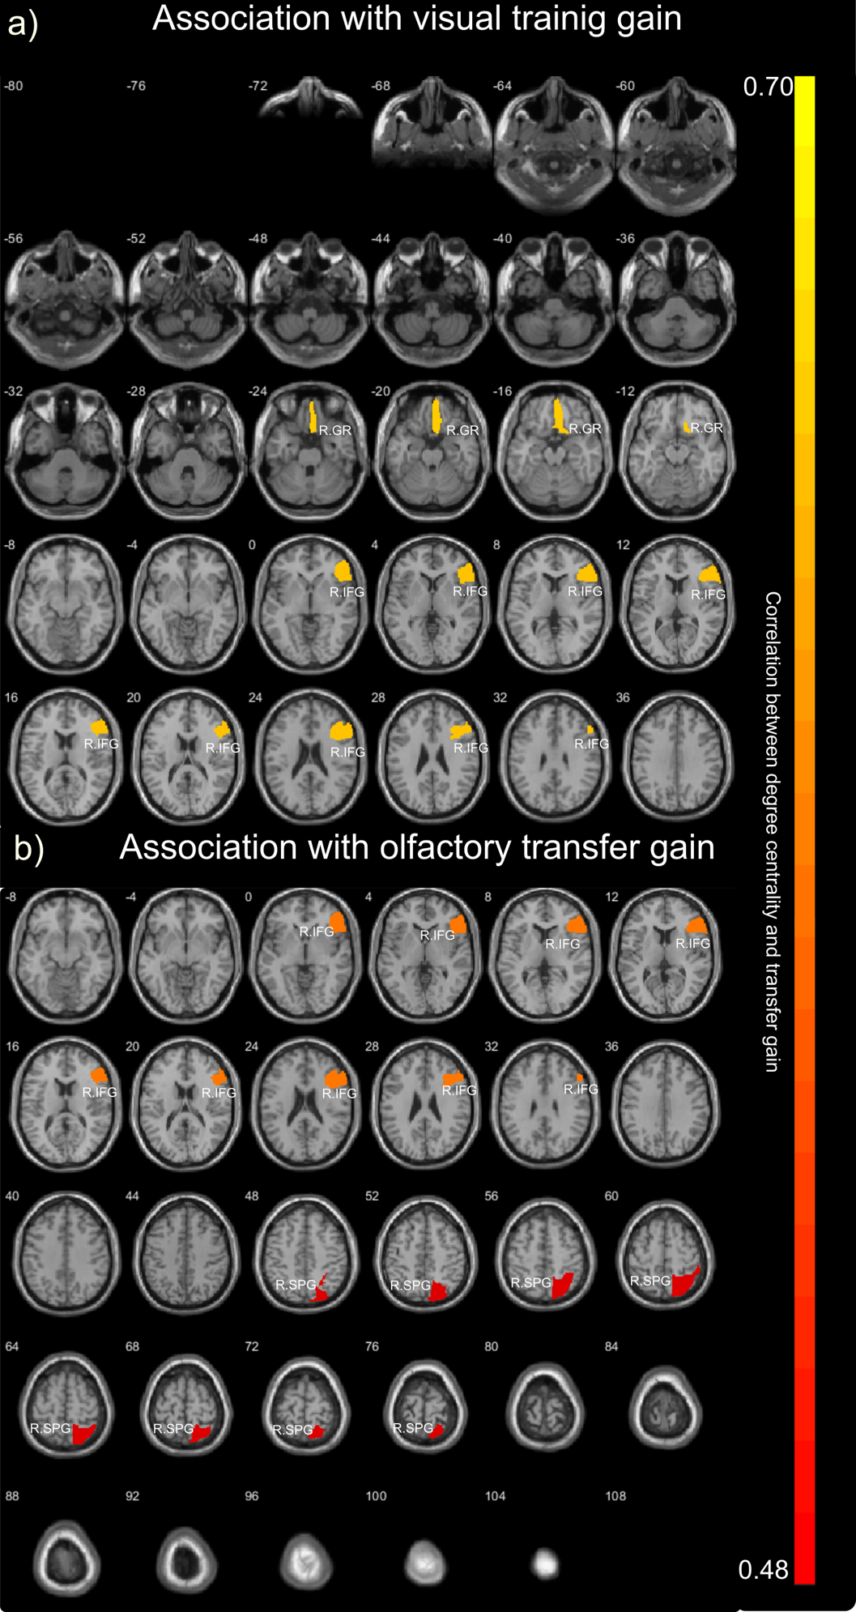

# Discussion

With increasing research evidence suggesting behavioral improvements from olfactory-based sensory training (Morquecho-Campos, Larsson, Boesveldt, & Olofsson, 2019), we here investigated how olfactory-based memory training might benefit non-olfactory tasks and cortical networks in old adults, a group where olfactory impairments often precede more severe cognitive impairments (Ekström et al., 2017; Olofsson et al., 2009).

In this randomized control trial, we showed that old adults benefitted from olfactory-based memory training and that their gains transferred to a visual control task, whereas the control group that trained on the visual memory task showed no benefits outside of the trained task. These findings show that although older adults have often achieve less training and transfer gains, the effects were in fact similar to those observed previously in younger adults.

The memory training was associated with cortical activity changes that differed depending on what sensory materials were part of the training protocol. Olfactory training led to increased connectivity of fronto-parietal cortices. Similar changes were observed in a prior study where odor identification was trained (Fournel et al., 2017). Although that previous study did not include a control task and thus the researchers were not able to make claims about olfactory-specificity, we find striking effects caused by our olfactory memory training task, but not in the visual memory training task. Based on the similarities across studies, we propose that the fronto-parietal network is involved in establishing multisensory or semantic representations that make odors recognizable or localizable.

We found only limited evidence of transfer to unrelated tasks. The transfer effects from olfactory to visual memory performance was moderate in size, but no other transfer effect was confidently different from zero.

Among the limitations is the relatively small sample size, with 41 participants completing training, as well as pre-training and post-training assessments of perceptual and cognitive abilities and MRI. Ideally, larger sample sizes might have been needed to precisely establish the behavioral effects of the memory training intervention, as effects are likely smaller in older individuals. The present study, however, included 82 sessions with MRI, cognitive and olfactory assessment, and over 1600 at-home training sessions with documented performance levels. The large comittment from participants makes the present study relatively ambitious in its scope. A passive control group would also have been useful to contrast effects of training to no-training groups, as this would account for possible test-retest. However, our prior work suggests no such test-retest effects are present, at least not in the olfactory assessments (Olofsson et al submitted).

# Supplementary

For olfactory group, one cluster in occipital lobe was founded (p < 0.0001 unc. k = 50) that it shrinks from pre-condition to post condition (Figure 1.). Two clusters (p< 0.0005 unc. k = 50) identified which showed increase in volume for train gain (Figure 2.). and two other clusters (p< 0.0005 unc. k = 50) showed increase in volume more for transfer gain rather than train gain (Figure 3.)

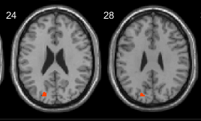

Figure 10. Pre-training - post-training condition in olfactory group

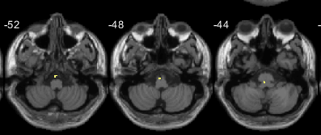

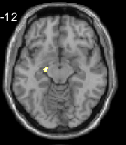

Figure 11. Hippocampus and Medulla increased volume associated with train gain in olfactory group